Design of an automatic machine

1- Introduction

The industrial test case is an automatic machine to produce soap.  
The machine involves 3 subsystems:

* Press
* Upload of raw material
* Turning pad

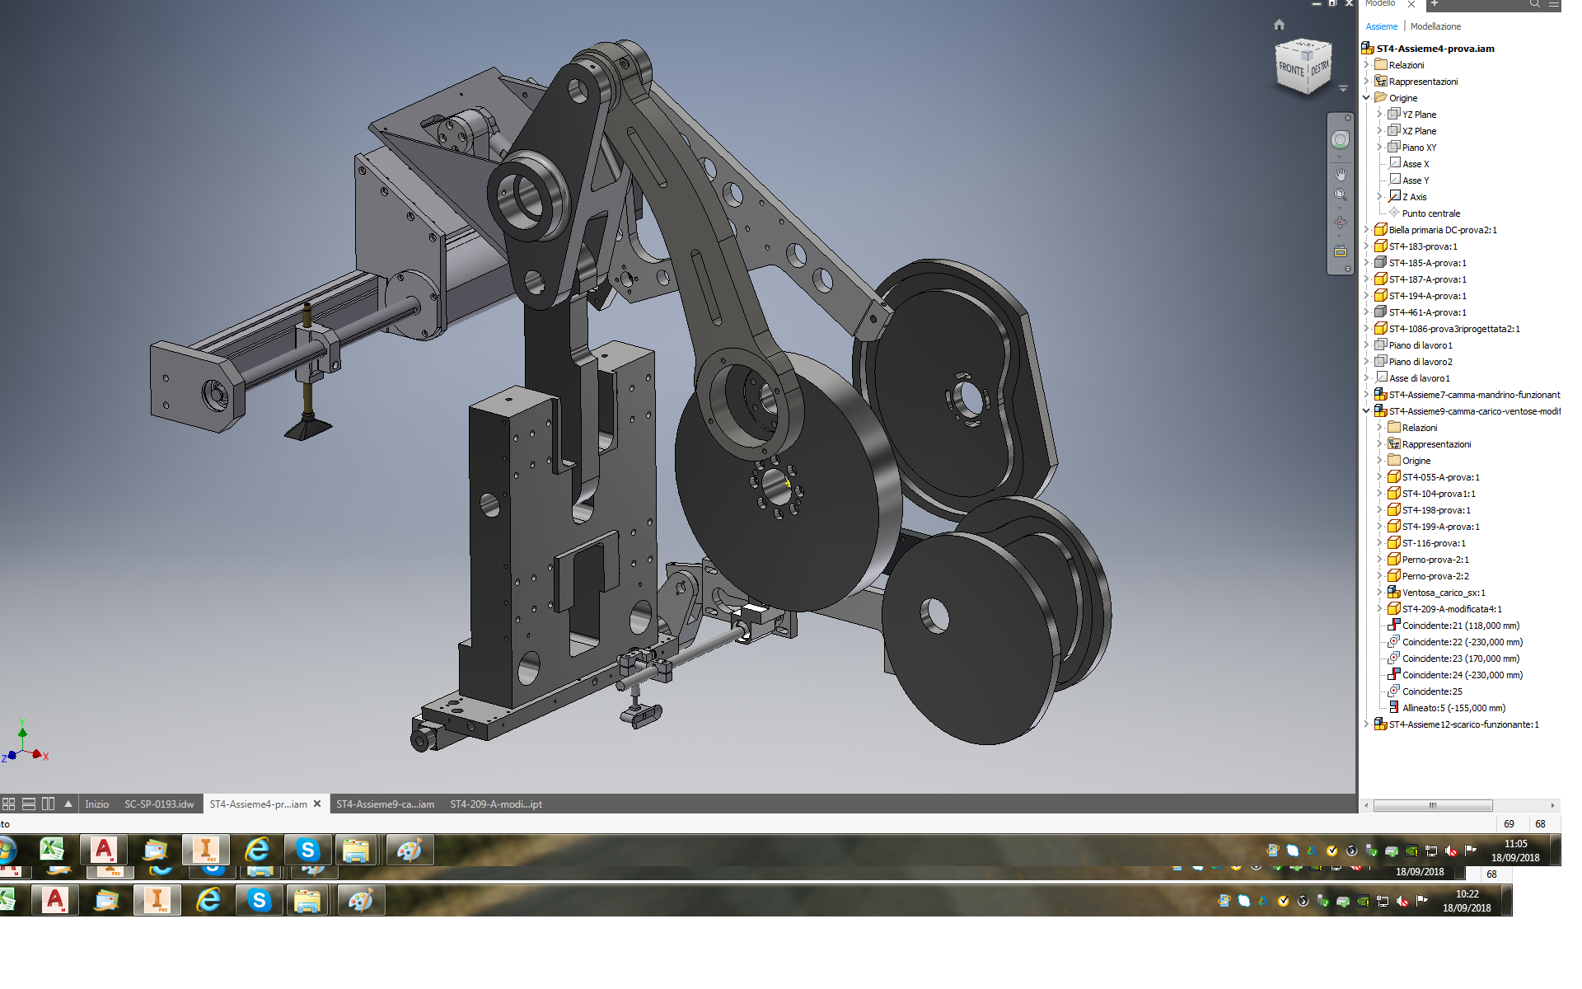



## Press Subsystem

This subsystem has the purpose of applying a high force on rough pieces of soap in order to deform them and make them assume the desired shape.

## Uploading Subsystem

This subsystem is designed to obtain a complex motion in order to charge the raw material onto the tilting pad.  
this complex motion can be divided into a linear displacement along a horizontal axis (x) and a rotation around the orthogonal axis ().

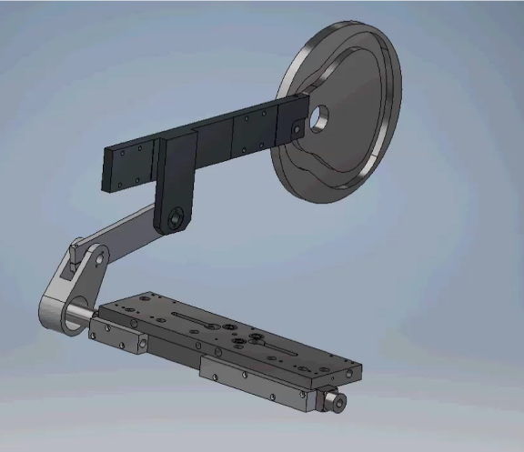

## Tilting pad

The porpoise of this subsystem is to support the raw material until is shaped by the press and then rotate to allow the discharge subsystem to pick the final product.

The aim of this report is to design one Subsystems at wish and to critically evaluate the feasibility of the solution.

# Tilting pad

This report is focused on the analysis of the Tilting pad. The tilting pad motion is a pure rotation and takes place around a fixed axis. The movement is realized through a slider crank mechanism which is actuated by a translating cam.

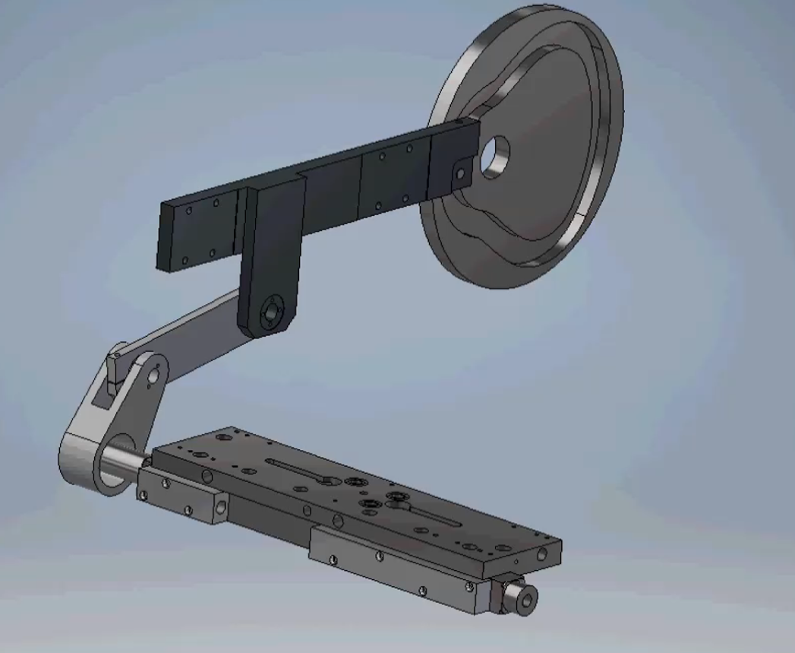

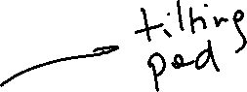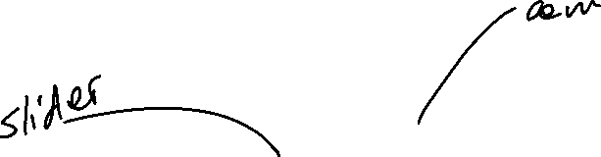

Considering that the driving element moves with a constant angular speed, it is necessary to:

1. Design the motion law of the tilting pad
2. Synthesize the slider crank mechanism and the cam mechanisms with a translating follower
3. Analyse the mechanism through kinematic parameters (transmission angle, pressure angle and undercut) and compute the motion law obtained with the designed mechanism
4. Calculate forces transmitted and the motor torque with a multibody model.
5. Critically evaluate the feasibility of the system

Design of the motion law

The motion law of the tilting pad should fulfil some given requirements, for each of these positions of the master angle, the tilting pad must be located at the given angular positions.

|  |  |
| --- | --- |
| Master angle | Angular pos. (°) |
| a = 0° | q = 45° |
| a = 70° | q = 0° |
| a = 200° | q = 0° |
| a = 360° | q = 45° |

As is known, the discharge subsystem needs time to pick the final product so the tilting pad has to remain still for a while at 45 degrees: another precision point is added.

|  |  |
| --- | --- |
| Master angle | Angular position (°) |
| 0 | 45 |
| 5 | 45 |
| 70 | 0 |
| 200 | 0 |
| 360 | 45 |